SET 4
Q1. Design an E-commerce Product Inventory schema using AI-assisted SQL generation.
• Include tables: Products, Suppliers, and Stock.
• Write SQL query to insert random data in each table
• Write an SQL query to find products with stock quantity less than 10.

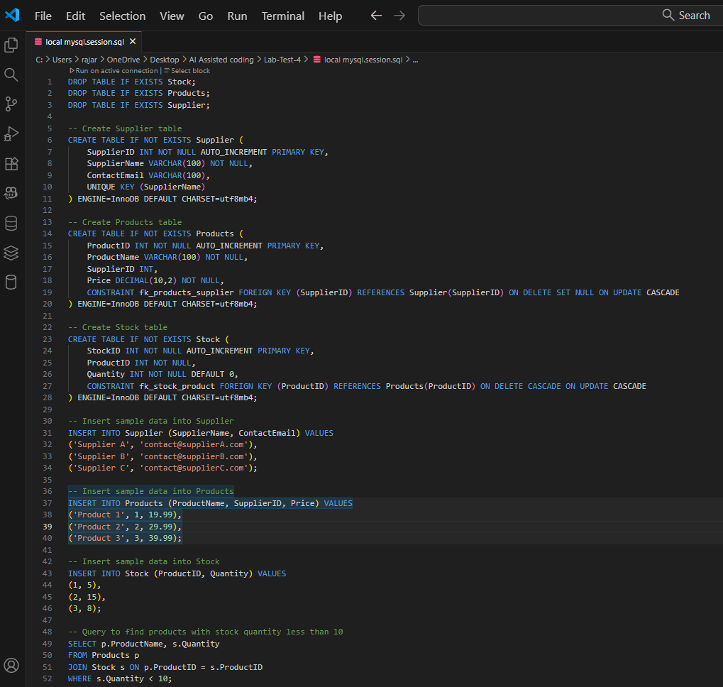

Q2. Generate an AI-assisted data cleaning script to:
• Generate dataset using ChatGPT that helps to complete the below two tasks
• Remove duplicates, handle NaN values, and standardize column names.
• Demonstrate the result using a sample CSV file

